**Report on Haines Solar Cooker Training**

**Dadaab Refugee Camp, Kenya**

**June 13 -23, 2022**

**By Adhieu Achuil Kueth, Facilitator**

**Dated: July 28, 2022**

**Project Purpose**

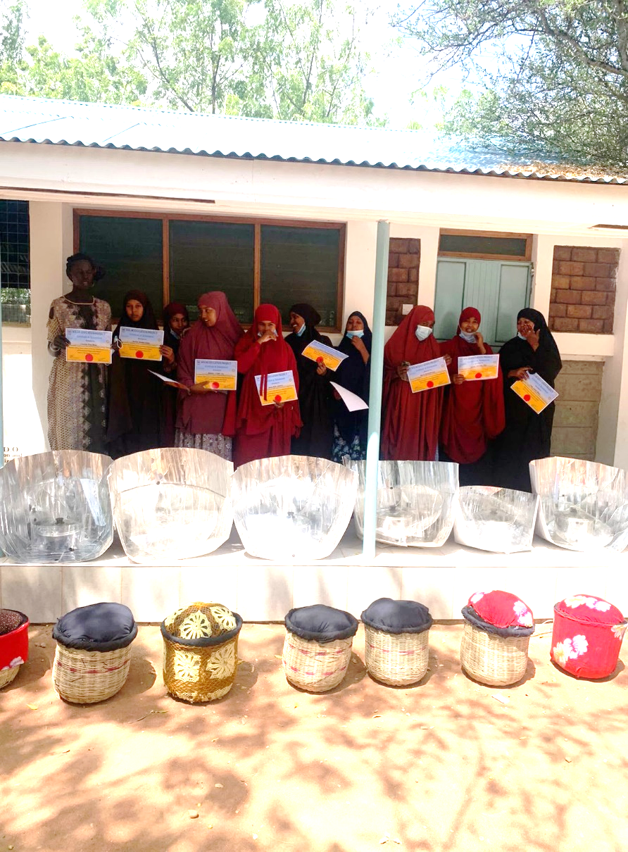The purpose of this project was to test the performance and acceptability of the new Haines Pop Open solar cooker by training a ten-woman focus group in solar cooking and the use of heat-retaining baskets to keep the evening meal hot until after sundown.

**Partners**

The training venue in Dadaab was provided by Relief, Reconstruction and Development Organization (RRDO), in cooperation with UNHCR. The training manual was written by Mary Buchenic and Jennifer Gasser of the Solar Education Project. Materials and instructions to make the Haines Pop Open Solar Cookers were provided by Haines Solar Cookers LLC. Funding in the amount of $1,000 was provided by the Rotary Club of Cashmere, Washington, and facilitated by Solar Household Energy, a Washington, D.C. promoter of solar cooking.

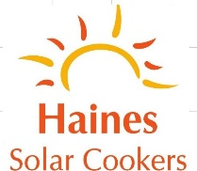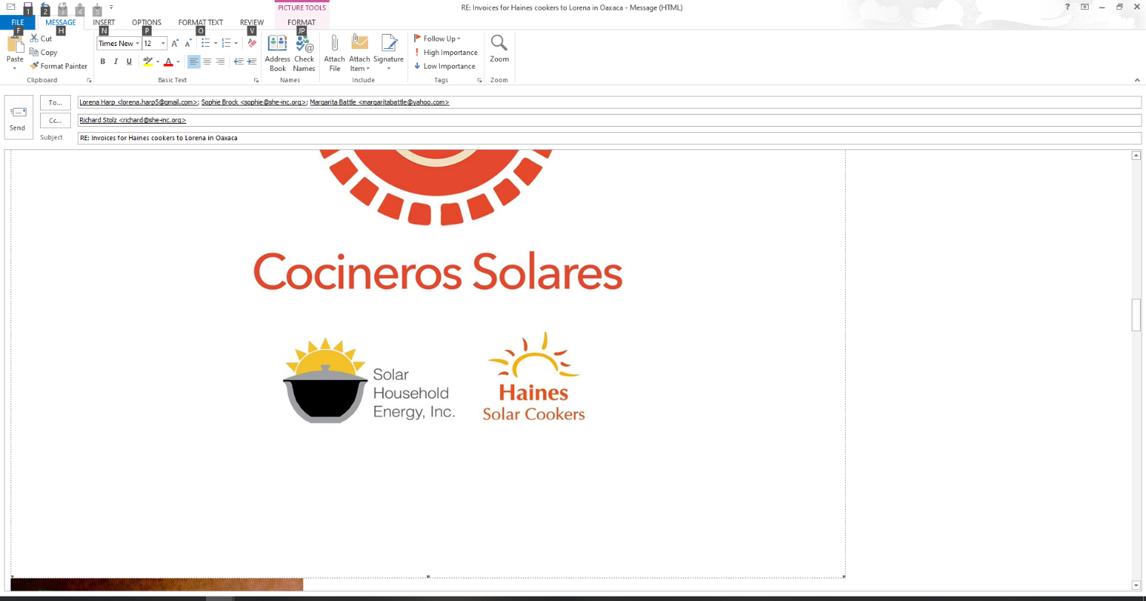

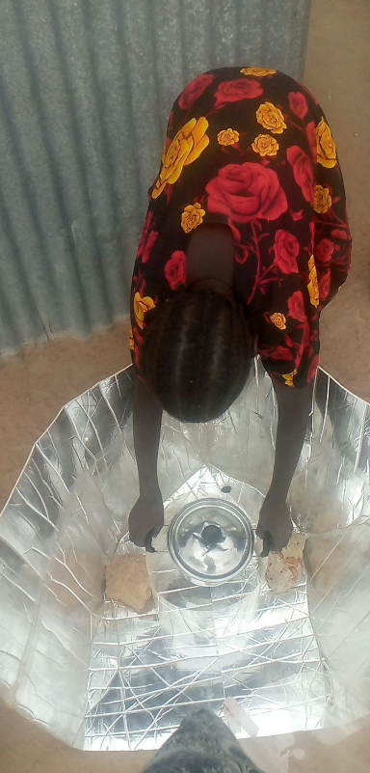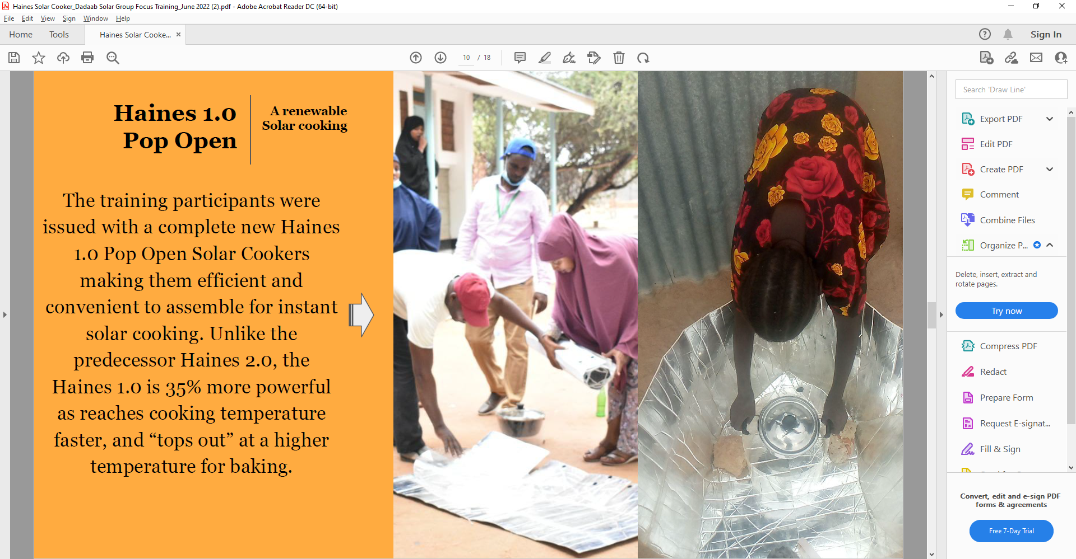**Method**

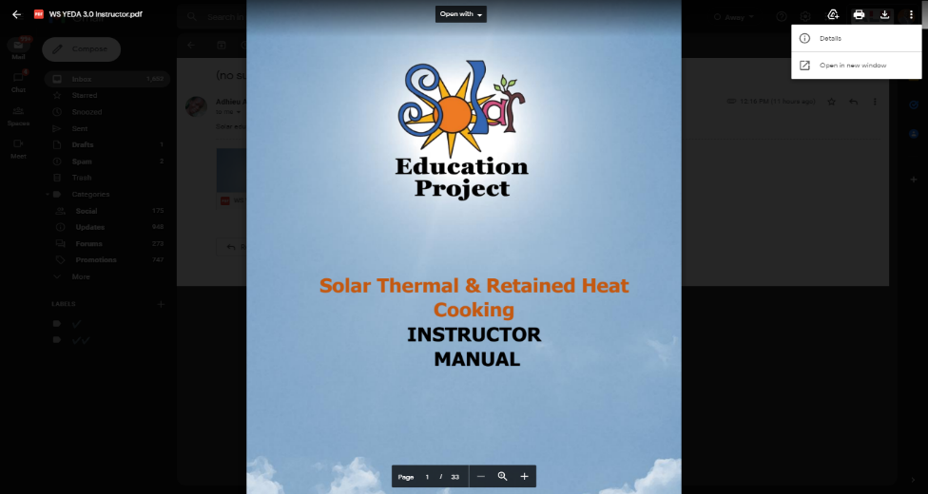The solar cookers were made by RRDO from rolls of reflective material, plastic sheets, “velcro” hook and loop fasteners and packaging tape supplied by Haines Solar Cookers. A total of ten refugee women were selected by RRDO from three areas —Dadaab, IFO and Dagahaley refugee Camps. The women comprised a “focus group” to receive training in how to cook with the sun, using the newly-designed Haines 1 Pop Open Solar Cooker. The training was for ten days, including three days devoted to making and using heat-retaining baskets to keep the evening meal hot until after sundown.

The trainer, Ms. Adhieu Achuil Kueth, used a workbook and teacher’s manual written for this project by the Solar Education Project. The training included a discussion of the scientific concepts underlying solar cooking as well as hands-on cooking. The women also made their own heat-retaining baskets to keep solar-cooker food hot until after dark for the evening meal.

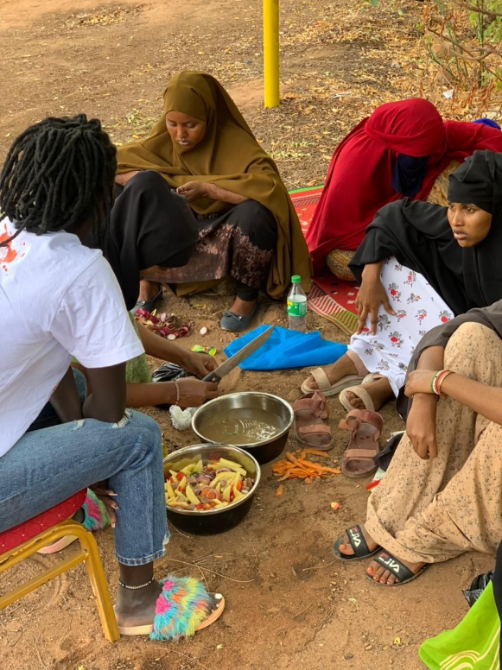At the end of the training, a graduation ceremony was held. The women were awarded certificates showing that they had been trained in solar cooking and heat-retention baskets. And they were allowed to keep their Haines Solar Cookers and the heat-retaining baskets that they had made.

A WhatsApp group was created with the cell phone numbers of each of the women, the trainer, and the Solar Education Project, so that the women could stay in touch with each other and report their solar cooking experiences on an ongoing basis.

**Comments from participants:**

*“A secure, inexpensive and a multi-tasking based cooking methods for preparing nutritious foods from the Sun’s heat.”*

**~Nyajima Tong**

*“I have never see heat from Sun cooking food until I used the Haines 1.0 Pop Open Solar Cooker”*

**~Suleka Abdi**

***UNHCR Community Protection Officer* *Mutisya Koki was happy to see heat retaining baskets being used with solar cookers:***

*“We’ve been using this heat retention basket in my village and they have been very much effective. Seeing Haines Solar incorporating them for the Haines Solar Cooking Pop Open is amazing.”*

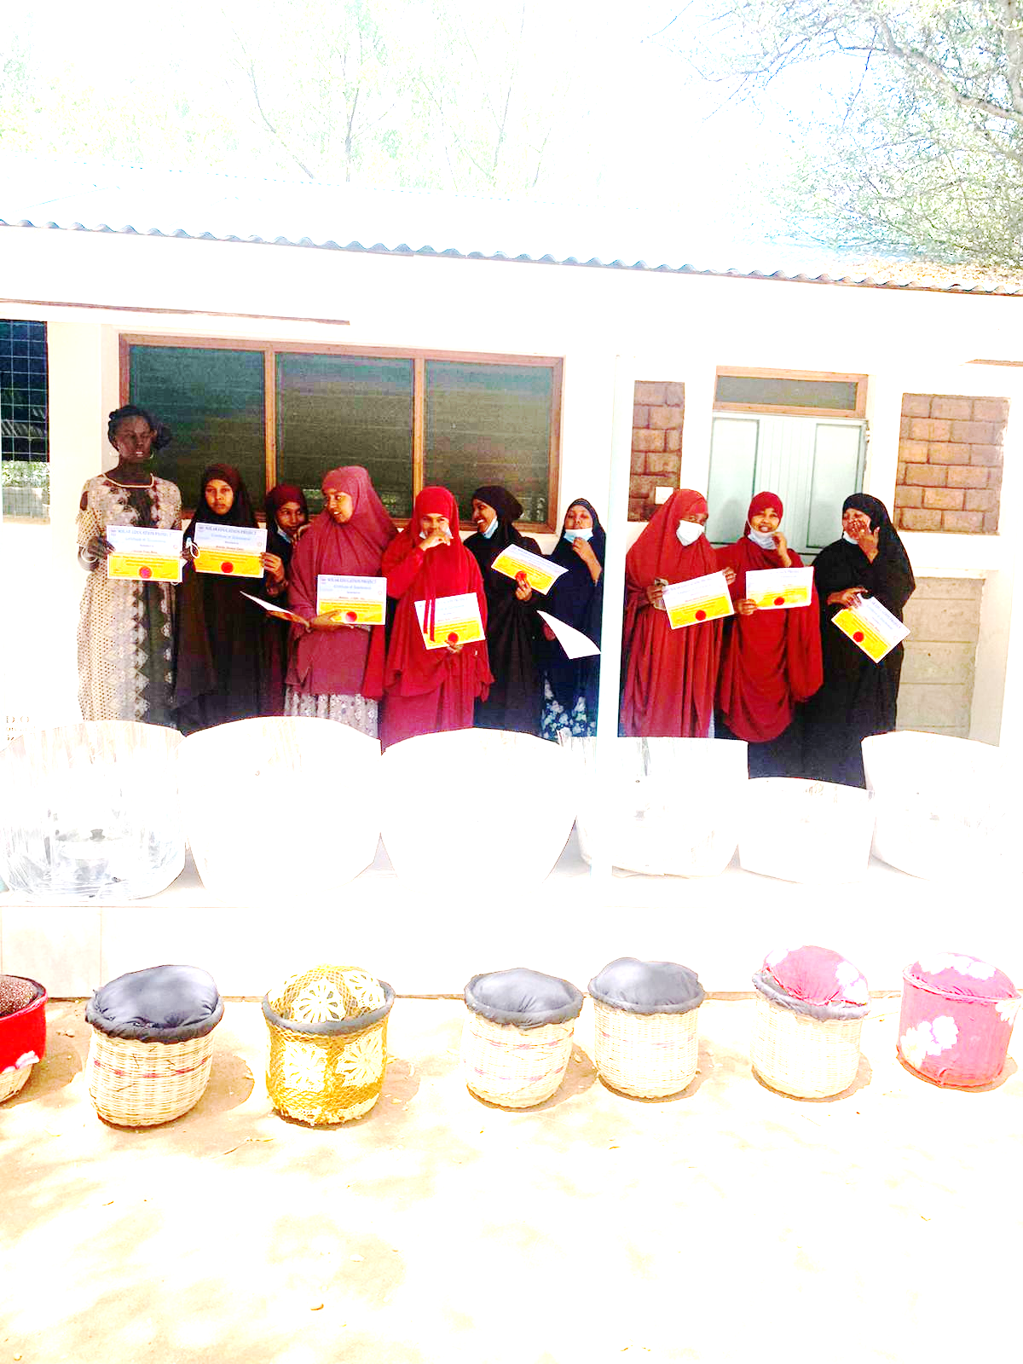

**Graduation**

Upon successful completion of the ten days of training, the participants from Dadaab, IFO and Dagahaley were awarded a certificate of completion in a graduation ceremony on June 23, 2022.

**What worked and what did not work for the 10 days Training**

The project was successful in providing ten days of solar cooker training to a ten-woman focus group, including three days of training in the use of heat-retaining baskets.

However, the team did not succeed in testing the Haines Pop-open Solar Cooker. There were three reasons for this:

1. **Instructions were too difficult**. Because “die-cut” Pop Open reflectors from China were not available, the project adjusted to have the Pop Open reflectors cut from existing rolls of reflective material. However, this was not possible because the instructions were too complicated—not just for RRDO, but for a similar project in Kakuma Refugee Camp. So the Dadaab project used an earlier Haines design that was similar to the Haines Pop Open, but was held together with velcro hook and loop fasteners under the cooking pot—a location where high temperatures may cause the adhesive to melt.
2. **Weather was often cloudy**. The weather during the training was often cloudy or rainy. As a result, actual solar cooking occurred on only two of the ten training days. Thus, the training consisted mostly of “book-learning.”
3. **Per diem and food budget were too low**. The project budget of $1 a day for food and $1 per diem resulted in a strong objection from the women on the first day of training. They demanded $10 per diem. However, an agreement was reached to pay $5 per diem, $3 of which came from RRDO. Nevertheless, it appears that the inadequate budget created considerable ill will that dampened enthusiasm for the project.

Despite the problems encountered, three participants have posted their cooking reports on the WhatsApp group following the training. They have shared photos of using the Haines solar cooker at home to make rice, yellow beans, swumamwaki, meat, and tea. One woman, in particular, has posted four separate times and is clearly interested in this new cooking technology. Her interest should be encouraged as part of the follow up.

**Importance of Similar Project in Kakuma**

As mentioned above, two weeks before the Dadaab project, a similar project trained a 10-woman “focus group” in Kakuma Refugee Camp in Kenya. As in Dadaab, the instructions for making Pop Open cookers from existing materials proved too difficult. So, as in Dadaab, an earlier Haines design was used for the training.

Despite this, the project in Kakuma has proven to be very successful. Two months into the project, the “focus group” women continue to post logs of their solar cooking activities for the WhatsApp group, and to post photos of the food that they have cooked. Critical to the success of the Kakuma project has been the active “cheerleading” of the WhatsApp group women by Jennifer Gasser and Mary Buchenic of the Solar Education Project, who wrote the curriculum for both the Kakuma and Dadaab projects.

Recently, the photographer for the Kakuma project, Bruno Kihuha, succeeded in making ten Haines Pop Open cookers from existing materials. These were distributed to the ten “focus group” women in Kakuma on July 25, 2022 at the office of the host CBO for the project, Youth Education and Development Association (YEDA). A number of women have posted photos and descriptions of their success cooking with the new Pop Open cookers. An analysis of the WhatsApp group’s postings will be part of an evaluation report on the Kakuma project that should be completed soon.

**Eldoret Project**. A ten-day training project for 20 participants is planned for Eldoret, Kenya on August 25, 2022. This time Haines Pop Open cookers will be used, and we will apply the lessons learned in Kakuma and Dadaab to insure that this project provides a rigorous test of the Haines Pop Open cooker.

**Facilitator’s Recommendations**

Here are my recommendations:

* **Wide scale introduction of the Haines Solar Cookers within the Dadaab communities**: Refugee agencies such as UNHCR and partners should invest in the solar cookers and introduce it on a wide scale to the refugee communities.
* **Alignment of the Focus Group Training with Kenya’s Climate Policy:** Kenya is pressing ahead with the promotion of the transition to clean cooking with alternative clean fuels. Such clean cooking fuels which include the Haines Solar Cookers can be integrated into the country climate policy.
* **Reimagine cooking education**: Haines Solar Cookers LLC and partners such as the Education Project should continue reimagining solar cooking education in a way that is culturally responsive, renewable, sustainable and contributes to a healthy lifestyle
* **Empowering Community Based Organization(CBO) to Independently Implement the Solar Cooker Training:**  Concerned CBOs should be fully empowered and encouraged to consistently ensure project implementation.